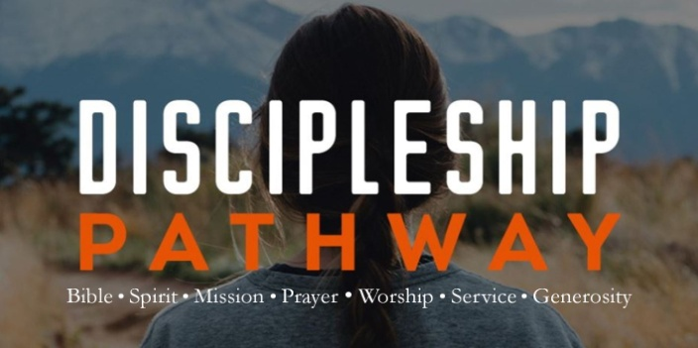
Matthew 6:9-13
A. Our Father: Worship
- God is our Abba Father; Romans 8:15
- Our Father rules from Heaven and all things are under His Authority
B. Your kingdom come: Agreement
- God is Already at Work
- He is Lord and He is Master
- We pray for His Will to be done
- On Earth as it is in Heaven
C. Give us this day our daily bread: Thanksgiving
- Give thanks for the bread God has already Supplied
- Develop a Grateful Heart
D. Give us this day our daily bread: Specific Requests
- Ask God to meet Particular needs in your life
- God Invites you to come to Him with Confidence and Boldness to receive answers to your requests from Him
- It is a Privilege to present our petitions to Him
E. Forgive us our debts, as we forgive our debtors: Confession
  - Do an Inventory and ask God to Forgive you for whatever you might have thought, said, or done that is offensive to Him
  - Choose to forgive those who have Offended you
  - Prayer is a time to Assess the condition of your heart
F. Lead us not into temptation but deliver us from evil: Spiritual Warfare
G. Yours is the kingdom and power and glory forever: Worship
  - We Begin with Worship and we End with Worship
  - Jesus declared His Father is Ruler of heaven and has All authority
Honolulu Assembly of God Discipleship Pathway March 13, 2022

