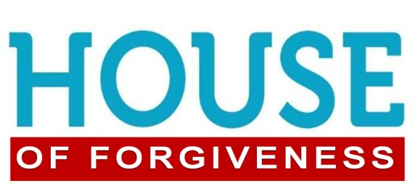
Ephesians 4:32; John 8:1-11
1. Christ’s Forgiveness for Us (The forgiveness we Receive)
- It is not based upon the Size or Seriousness of our Sin
- Sin is Terrible; it is Huge
- Sin literally means to miss the Mark
- There are two Extremes regarding Sin
- My sin is too Big and too Bad for Christ to forgive
- I’m not nearly as Bad as you are; I’m OK
- The Truth of Scripture
- We are All sinners in need of a Savior
- We are All in need of Forgiveness
- Our Forgiveness is based on the size of Christ’s Marvelous Grace
- It is available to Everyone
- Christ’s grace is Endless
- Our Sins are Forgiven and Forgotten
- They are Removed as far as the East is from the West; Psalm 103:12
- We don’t have to carry them Anymore
2. Our Forgiveness for Others (The forgiveness we Give)
- People desperately need to Receive it
- They might try to Ignore their need, even Blame it on others
- Yet people continue to Long for Forgiveness
- We desperately need to Give It
- Many Hurting and Broken people will walk into your life
- Two Complications in becoming the Church where Forgiveness is
- If a Christian, it is easy to Forget your own past failures
- Too often the church is known for what we are Against
- Let’s Be a House of Forgiveness!
Honolulu Assembly of God Welcome to the House January 22, 2023

