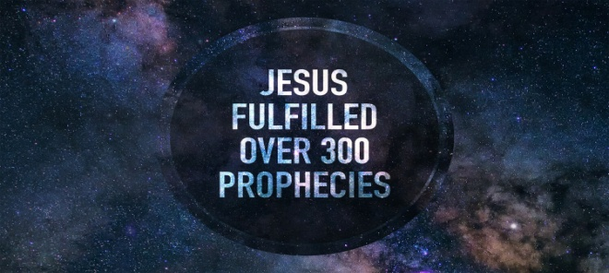
Born of a Virgin: His Divinity!
Isaiah 7:14; Matthew 1:22-23
1. His Divinity is Essential to His Incarnation; Hebrews 1:1-3
- Jesus is the Perfect Union of God and Man
- He did not just Live among us; He Became one of us
- Jesus is Immanuel: God with us
- God is not Far off; Jesus brings Him into View
- Jesus is the Father’s Perfect Communication
- The Father desired to communicate with His created ones from the Beginning via Creation, the Nation of Israel, and the Prophets
- Now He has spoken to us by His Son
2. His Divinity is Essential to Our Salvation; Romans 3:23-26
- His Divinity solves the Divine Dilemma
- How can God be Just and also the Justifier?
- The Solution: Take the penalty upon Himself
- The One Taking the punishment must be same as the One who Set the punishment; He is our Great Substitute
- His Divinity enables Him to be the Perfect Sacrifice
- In the Old Testament, animals were Continually sacrificed but could only Temporarily cover sin
- Jesus is the Perfect Lamb whose One sacrifice covers All sin for All time
- All other sacrifices and efforts were Futile, but Jesus’ work was Effective; He then Sat down at the Right hand of the Father
Honolulu Assembly of God Old Testament Prophecies of Christ! December 4, 2022

