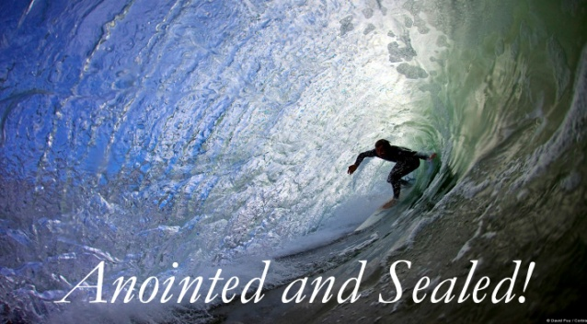
2 Corinthians 1:21-22
1. You are Anointed
- As Prophet
- Not the Gift of a prophet but the Ministry of a prophet
- The prophet proclaimed the Word of the Lord
- It was not just Fore-telling but mainly Forth-telling; It was not just Prediction but Proclamation
- We are a prophet when we proclaim the message of Salvation
- As Priest
- Whereas the prophet brought God to the People, the priest brought the people to God
- Now we all have Access into the presence of God; 1 Peter 2:9
- We have no need for an Earthly priest; we have One High Priest and we are All priests before Him
- As King
- We shall Rule and Reign with Jesus for all Eternity; Revelation 1:6
- You are also Ruling and Reigning with Jesus Christ – Now
- Do not live like a Commoner; Live as a Prince and Princess
2. You are Sealed
- Ownership
- God placed His seal upon you and says “You are Mine!”
- Authority
- Letters sealed in the King’s name carried the same authority as if they were from the King
- We do not walk in our Own authority but in His
- Security
- You have Protection from the enemy and security for the Future
- Validation of the relationship
- The Holy Spirit is the symbol of God’s Love for you
Honolulu Assembly of God A Brand New You June 13, 2021

