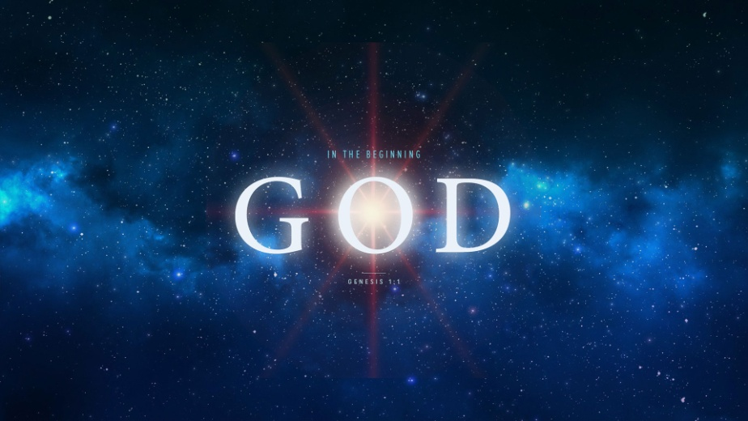
Sexuality and True Intimacy
Genesis 2:20-25
1. Sexuality
- Sex is Good
- The Devil did not create sex; He corrupted it
- God created sex; Everything God made He declared Good
- Sex is Wonderful; God created Sex as a Gift for you
- Sex is a gift to be Cherished and Treasured
- Too many people are giving precious gift Away
- Sex is Beautiful but only Inside the Bond of Marriage
- Why is the Bible so Outspoken about sexual sin?
- Marriage is the Picture of Christ’s relationship to His Church; Satan’s plan is to Corrupt that picture
- God desires to Protect us and picture of Marriage
2. True Intimacy
- Adam and Eve knew True Intimacy in the Garden
- They were both Naked and were not Ashamed
- Their phys nakedness represented their complete Transparency before God and one another
- The Problem of Non-Intimacy
- What is the Solution?
- God has provided Avenues to True Intimacy
- Christian Marriage
- The Church
Honolulu Assembly of God In the Beginning God! August 16, 2018

