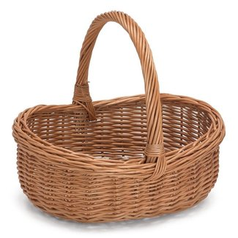
What’s in Your Basket?
Ruth 1-4
A. Ruth is at a crisis point; the basket of her life is Empty.
- She looks for what has the most Value for her Future and begins to Glean, adding to her life’s basket.
- She adds Relationship with God and with People. Ruth 1:16
- She adds Initiative to work. Ruth 2:2, 5-7
- She adds Resources from her work. Ruth 2:17, Galatians 6:9
- She adds Generosity. Ruth 2:18
- She adds Honor. Ruth 3:1-6
- Her basket looks Full, but God says there is room for More!
- He adds the Overflow of Blessing.
- He adds More than she had Lost.
- He adds a Hope and a Future. Jeremiah 29:11
B. What’s in My life’s basket?
- What am I adding of Value for my Future into my basket?
- The most important to add is a Close relationship with Jesus.
- As I give Him First place in my life and add what has Value, He adds Blessing. Matthew 6:33
- He adds a Hope and a Future. Jeremiah 29:11
Honolulu Assembly of God Mother’s Day May 8, 2022

