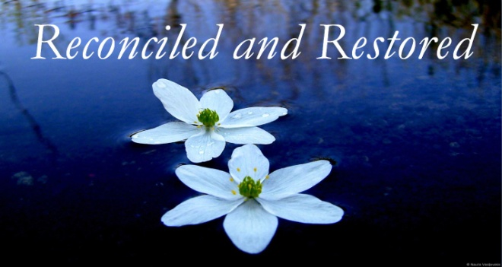
2 Corinthians 5:17-21; Luke 15:22-24
1. You are Reconciled
- The Process of Reconciliation
- Definition: “To bring back Together; make Consistent”
- Offering a Gift at the altar (Matthew 5:23-24) and the Marriage relationship (1 Corinthians 7:10-11)
- Christ’s Work of Reconciliation
- His death on the cross satisfied the Demands of a holy God
- You are not just Pardoned from sin, you are Reconciled to the Father; Ephesians 2:11-22; Romans 5:8-11
- The Ministry of Reconciliation; 2 Corinthians 5:17-21
- We are first reconciled to God (Vertical) and then reconciled to Man (Horizontal)
2. You are Restored
- The Process of Restoration
- Charles Hodge: “A pardoned criminal may be restored to his civil rights, so far as the penalty remitted involved their forfeiture, but he is not reconciled to society. He is not restored to favor. Justification, however, does secure a restoration to the favor and fellowship of God. We become sons of God by faith in Jesus Christ.”
- The Reality of Restoration
- The Shunammite Woman (2 Kings 8:1-6) and the Prodigal Son (Luke 15:22-24)
- The Ministry of Restoration
- Galatians 6:1 “Brothers, if someone is caught in a sin, you who are Spiritual should restore him Gently.”
- There is great Power in Restoration
Honolulu Assembly of God A Brand New You June 6, 2021

