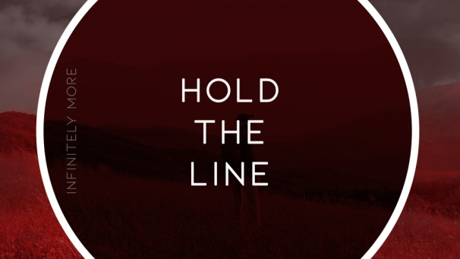
Ephesians 3:20
God sees Infinitely More in you than you see in yourself.
Our faith is not built on just one moment or one decision but on multiple moments and decisions in our faith journey. Each day we are making decisions. As we follow Jesus and build our life, He wants to make sure we build a secure and immovable foundation, one that is rock solid!
Much like a hanging plumb line shows a builder the exact line to follow, God is declaring there is only one way to follow Him. There is one set of boundaries for a relationship to be built on.
If you stay committed to the line that God has drawn, then you will be blessed by Him. But if you step away from the line, you are breaking the ties of the relationship, risk losing God’s protection and will miss out on His guidance and blessing.
1. Hold tight to your commitment to God
- Strengthen your commitment to God by having a consistent personal daily Quiet Time
- Read your Bible. Truth is the only way you can battle the lies of the enemy
- Develop a prayer life that allows you to Listen as much as you talk to God
2. Hold tight to your commitment to Others
- Guard your heart and your responses
- Commit to living in such a way that will bring blessing and favor into your life
- God can use others to help strengthen your grip on the line; we need one another
Honolulu Assembly of God Infinitely More! May 3, 2020

