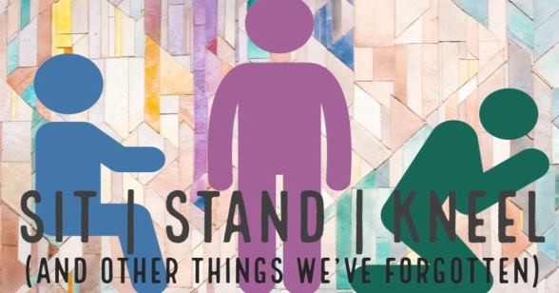
Choose Your Posture!
Matthew 20:26-28; Luke 10:38-42; Hebrews 10:35-39
A. Kneel
- Kneel to Serve; John 13:1-5
- There are too many Christian Stars and not enough Servants
- Kneel in Humility
- Swallow your Pride and let go of your Ego
- The greater the Christian Growth, the greater the Humility
B. Sit
- Sit to Learn; Luke 10:38-42
- Sit at the Feet of Jesus and learn from Him
- Sit in Communion
- It is not about the Busy-ness of a Martha spirit but the Intimate relationship with Jesus that Mary had
C. Stand
- Stand in Faith; Ephesians 4:14
- Do not be Blown here and there by every wind of doctrine
- Stand in Freedom; Galatians 5:1
- Satan wants to Enslave you; Stand Firm in Christ’s liberty
- Stand in Worship; Nehemiah 9:5
- Stand up and Praise the Lord your God
- Stand in Perseverance; Hebrews 10:35-39
- Don’t Give up; Rise Up!
Honolulu Assembly of God Choices! August 22, 2021

