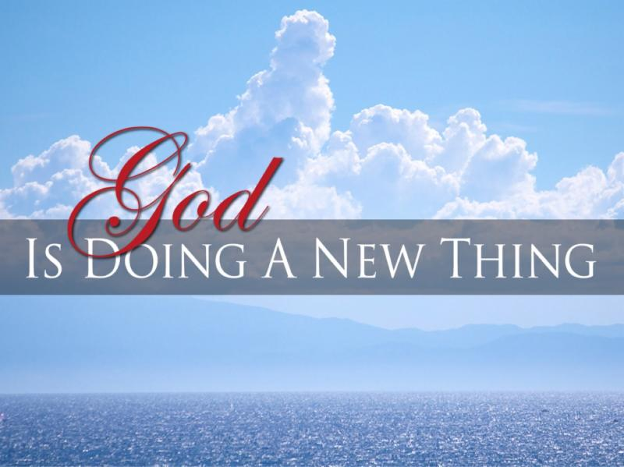
Philippians 3:12-14
1. New Mercies (Lamentations 3:22-23)
- You don’t have to live with Yesterday’s Mercies
- God generously gives you a new, Abundant supply each day
2. New Identity (1 Peter 2:9-10)
- Realize you are Unique in God’s sight
- He knows you by a Special Name that describes you as He sees you: Perfected in Christ; Philippians 1:6
3. Lessons to Learn
- You cannot depend upon your past Victories to Sustain you
- The question isn’t: What has God Done for you?
The question must be: What is God Doing in your life right now?
- You cannot Allow your past Failures to Control you
- God is offering you the Promise of Hope
- You cannot Live on Yesterday’s Blessing
- You need to Step Up and Step Out in Faith
4. Truths to Apply
- Expect God’s promises to Continue to be Fulfilled
- Put aside your Past
- Grab hold of your Future
- Rest in Jesus Christ Alone
Honolulu Assembly of God January 31, 2021

